Meusburger Georg GmbH & Co KG
Kesselstr. 42, 6960 Wolfurt, Austria

Meusburger sets standards at the wfb

From 7th until 8th of June the wfb trade fair for die and mould making took place in Augsburg. Also this year, the standard parts manufacturer Meusburger was represented with a stand. In addition to the standard components, it presented current new products. An active exchange took place not only at the stand, but also in the newly introduced campfire sessions. For the first time, the wfb offered to the visitors the opportunity to exchange information about specialised topics in small discussion groups.

Innovations and tried & trusted products
The Austrian standard parts manufacturer had some innovations to show in Augsburg. New products in the field of hydraulics, guiding and temperature regulation components, as well as electrical components were presented. In addition, extensions of the range of centring and marking stamps were introduced. Tried and trusted products like the clamping system H 1000 or the air cushioned assembly table attracted as great interest as ever. Particularly popular with visitors were the Meusburger change moulds in various sizes. These allow an easy change of inserts with repeatable accuracy and are therefore ideal for the production of small series and prototypes.

New concept with campfire atmosphere
A campfire is a small discussion round in which everyone can join in the discussion unannounced, independently of whether he is an exhibitor or a visitor. The sessions lasted between 30-45 minutes and took place on both trade fair afternoons. To enable an optimal interaction, the participants sat together on folding chairs in a small group forming a circle – like in a campfire. The conversations and discussions were led by an expert. The topic 'Milling, EDM, additive manufacturing or hybrid – which technologies are needed for die and mould making?' was moderated by Susanne Schröder, editor-in-chief of FORM+Werkzeug. Andreas Sutter, marketing director at Meusburger, led the group about 'Standardisation and automation in die and mould making despite batch size 1'. Conclusion of the wfb in Augsburg: the visitor numbers exceeded the expectations and the new concept of the campfire sessions was very well received by the participants.

Picture credits: Photo (Meusburger)

Caption: The Meusburger stand at the wfb – a must for every trade fair visitor
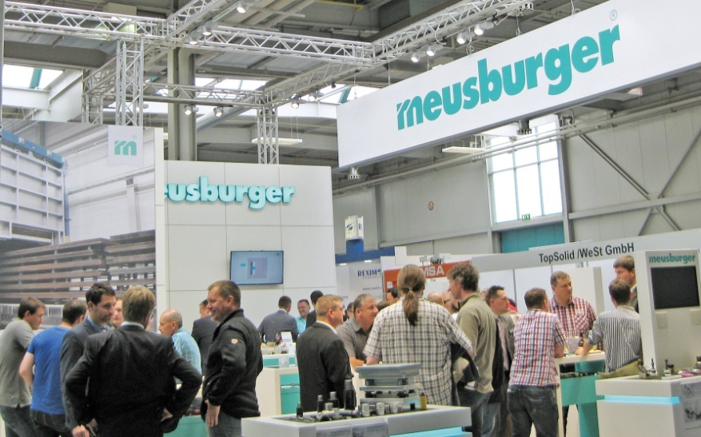

Caption: The small discussion groups with campfire atmosphere were very well received
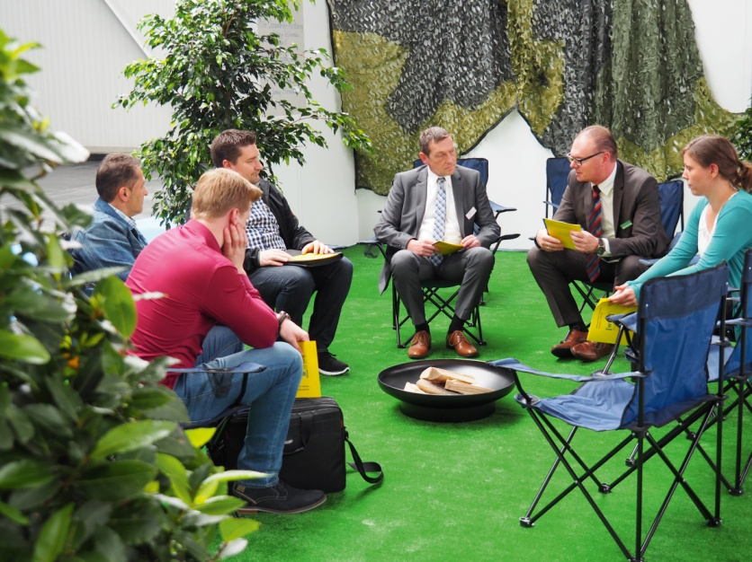

Further information:
Meusburger Georg GmbH & Co KG
Communication / Public relations
Phone: 0043 (0) 5574 6706-0
Email address: presse@meusburger.com
www.meusburger.com/press

Meusburger – Setting Standards
Meusburger is the leading manufacturer of high-precision standard parts. More than 17,000 customers all over the world make use of the numerous advantages of standardisation and benefit from the company's over 50 years of experience in working with steel. Offering an extensive range of standard parts, combined with high-grade products in the field of workshop equipment, Meusburger is the reliable global partner for making dies, moulds, jigs and fixtures.

