Meusburger Georg GmbH & Co KG
Kesselstr. 42, 6960 Wolfurt, Austria

Precision – the be-all and end-all in die making

A precise die set is indispensable for the production of an exact stamped part. Meusburger offers the perfect basis for a precision stamping die. The high-precision die plates in various materials and thicknesses are perfectly matched and designed for the modular concept.
An exact and dimensionally stable die set is crucial for the production of an exact stamped part with repeatable accuracy. Meusburger takes special measures to ensure this decisive precision. The standard stress-relieving heat treatment of all steel grades as well as the ideal temperature kept during production and storage reduce the warping of steel to a minimum. State-of-the-art machines produce high-precision plates from this starting material, which have identical dimensions and tolerance fields regardless of the steel grades. Strict machining guidelines and careful inspection with the Zeiss measuring system guarantee consistent quality. The standard parts for die making from Meusburger are perfectly matched and optimally suited for modularly built individual die sets with different combination options.

User-friendly design
Meusburger’s primary concern is to support die makers in the best possible way through the entire machining process. That is why Meusburger’s standard parts are designed to be very user-friendly, tested in practice and are constantly being further developed. For example, the alignment edges on the die plates serve to support parallel alignment on the machine. Perfectly coordinated pillar and bush holes with a hole distance tolerance of ±0.003 mm ensure for maximum precision and repeatability. The anti-rotation protection design allows the pillar to be installed in both the top and base plate. The clamp risers are machined as standard with a ventilation groove so that air can escape when the pillar is lowered into the sliding guides. In addition, Meusburger offers an optimally adapted and innovative range of accessories.
H 3000 - The innovative clamping system for die making
Meusburger has developed the innovative H 3000 Clamping system to support the die maker in the production of an exact and dimensionally perfect stamping die. The H 3000 is a clamping system for die making which facilitates the alignment of die plates on the machine. The alignment and clamping of the die plates in the guiding holes not only enables clamping with repeatable accuracy in the µ range and a significant reduction in set-up times, but also simplifies programming of the machine through clamping without interfering contours. The H 3000 Clamping system makes it easier for the die maker to manufacture a precision stamping die, which in turn significantly increases the quality of the stamped parts.
Securing competitive advantages in the long term
In summary, one can say that die makers can benefit in many ways from the consistent use of Meusburger standard parts because high-precision end products ultimately depend on high-precision die sets. Meusburger offers the perfect basis for this. The modular system allows an almost unlimited number of possible combinations – while maintaining the highest and most consistent precision.

Picture credits: Photo (Meusburger)
Caption: Meusburger offers the perfect basis for a precise stamping die

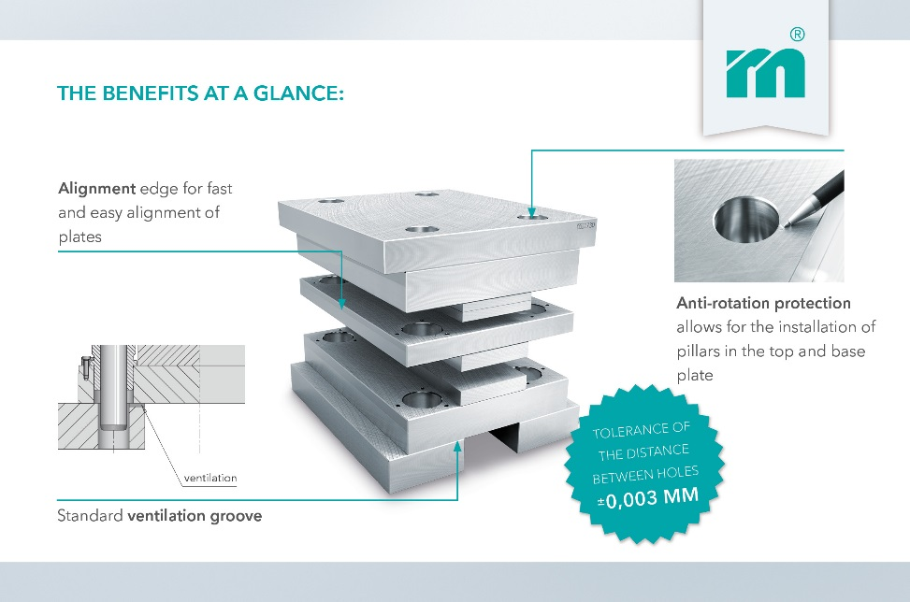

Meusburger – Setting Standards

As a part of the Meusburger Group, the Meusburger company is the market leader in the field of high-precision standard parts. Customers all over the world make use of the advantages of standardisation and benefit from the company's over 50 years of experience in working with steel. Offering an extensive range of standard parts, combined with selected products in the field of workshop equipment, Meusburger is the reliable global partner for making moulds, dies, jigs and fixtures.

Further information:
Meusburger Georg GmbH & Co KG
Communication / Public relations
Phone: + 43 5574 6706-0
Email: press@meusburger.compresse@meusburger.com
http://www.meusburger.com/en/press/press.html

